TITLE
  - Sub-title
A.N. Author & A.N. Other

This document is an example Word import template for the Content Catalyst technology platform. You can modify the Word paragraph styles and the headers and footers to suit your needs.
An import template is for internal use only and is not customer facing. They are designed to make sure documents can be created by your analysts and authors in a format that makes importing content into the platform easy.
Word contains certain paragraph styles that the Content Catalyst import system recognises and maps to in-platform styles automatically. You can create custom Word paragraph styles and map these Word paragraph styles to styles the platform recognises, or set that style to be ignored. For example the “Title” style used above is ignored by default as we don’t import into metadata from the document, we only import into the content of the report.
On import all headers and footers are discarded, so these can contain anything.
See the help centre for articles on formatting Word documents for import and configuring Word style import mapping.
At it’s most basic, a document prepared for import will start with a paragraph in the “Heading 1” style, and then contain paragraphs of text in the “Normal” style, but a more complex document would be built up from various conent styles, but may also have a cover page or pages that contain styles that are ignored on import. Note that for the content itself, it must begin with a “Heading 1” – any actual content before the first Heading 1 will be grouped into an “Untitled Chapter.”

Table of Contents – an import document can have a table of contents. It will be ignored on import as in-platform the table of contents is automatically generated from the headings within the document.

Heading 1 – a Chapter level heading 3
A level 2 heading. 3
A level 3 heading. 3

Table of Tables – an import document can have a table of tables. It will be ignored on import as in-platform the tables are available in the tables tab.

Tables require a title in the table title style 3

Table of Figures – an import document can have a table of figures. It will be ignored on import as in-platform the figures are available in the figures tab.

An image can have a figure title in the figure title style 3

Heading 1 – a Chapter level heading

A level 2 heading.

A level 3 heading.

A level 4 heading (lowest level heading)
These headings show in the navigation pane on the left. Note that you should not “jump” heading levels e.g. Heading level 1 followed by Heading level 3.
- 1st level bullets in the list paragraph style. Using the intrinsic property from word.
- 2nd level bullets in the summary style.
Text in the quotes style.
Text in the glossary style.
Tables require a title in the Exhibit Title style
Header | Header | Header
Data | Data | Data
Data | Data | Data
Data | Data | Data
Tables can optionally have a note in the Exhibit Note style. If they have a note, they must have a source.
Tables can optionally have a source in the Exhibit Source style.
To be a figure, an image requires a figure title in the Exhibit Title style
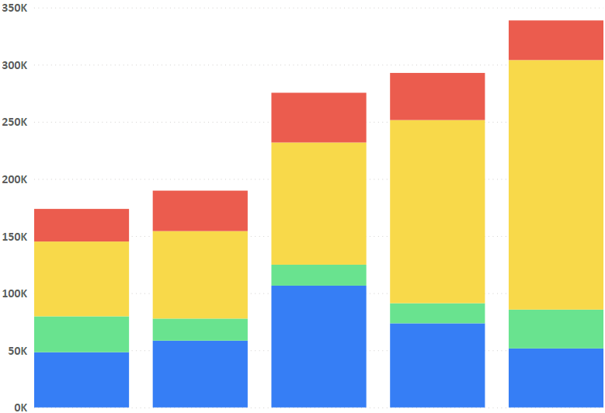
Figures can optionally have alternative text in the Alt Text style. If present, this overrides any alt text specified on the image.
Figures can optionally have a note in the Exhibit Note style. If they have a note, they must have a source.
Figures can optionally have a source in the Exhibit Source style

